Ohmic resistance and Ohm’s law
In this experiment, you will be using a resistor, with characteristics similar to the metals that make up wires and the heating elements in electrical appliances. You will discover the relationship known as ‘Ohms Law’

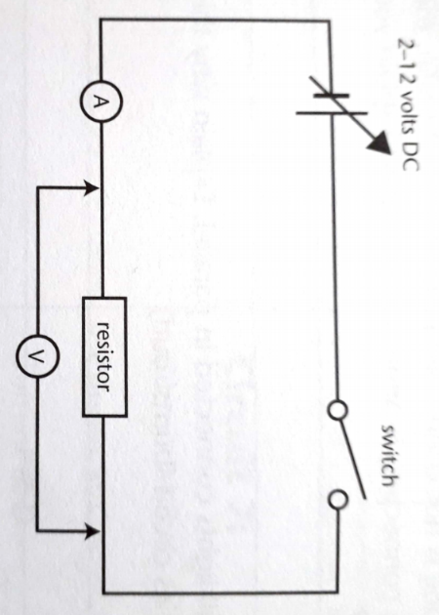
Diagram of the experiment

Results
- Record the current for voltages from 0 volts to the 12 volt setting of the power supply in a suitable results table.
- Plot the voltage (y-axis) against the current (x-axis).
- The gradient of the graph is called the ‘resistance’. From the graph calculate the resistance of your resistor.
- On your graph, draw a line you predict you could get a higher value resistance and one you could get for a line of lower value of resistance.

Safety
- Safety glasses are essential during the experiment.
- Ensure power is off when constructing circuits.
- Ensure all circuits are properly connected.

Ohmic resistance and Ohm’s Law
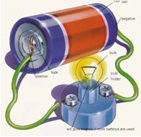
I In groups of 2-4, plan and conduct the Investigation.
Complete your write-up individually.
 |  | Mark Allocation | Mark
Title | - Title relevant and concise | 1
Aim and Hypothesis | - Aim is clear and concise  - Hypothesis relates independent and dependent variables | 2
Variables | - Independent variable is identified  - Dependant variable is identified  - 3-5 controlled variables identified | 3
Results | - Table includes title which relates variables  - Columns relate to independent and dependent variables and include headings with units  - Calculation of Gradient (resistance) | 3
Graph | - Graph title relates variables  - Graph type appropriate for data  - Axis correct orientation and labelled, including units  - Appropriate size and scale  - Predicted lines of lower and higher resistance values. | 5
Discussion | - Results summarised and patterns identified  - Explanation of results using scientific knowledge  - Difficulties or sources of error identified  - Specific suggestions for improvement or further experimentation | 4
Conclusion | - Summary of findings  - Hypothesis supported or not. | 2
Total
/20

